Bailey, Taylor 3/20/2018 18SP_F2 IST190 LINUX Essentials (W02)

Lab4

Lab4-7.4-12

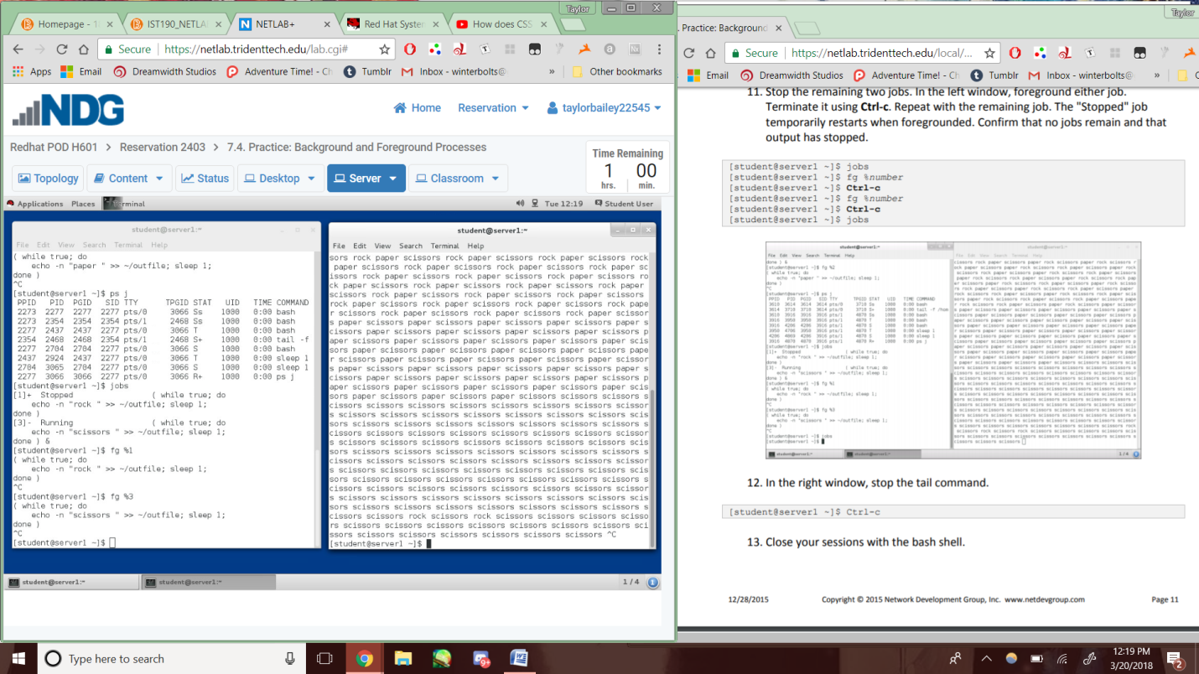

Lab4-7.6-7

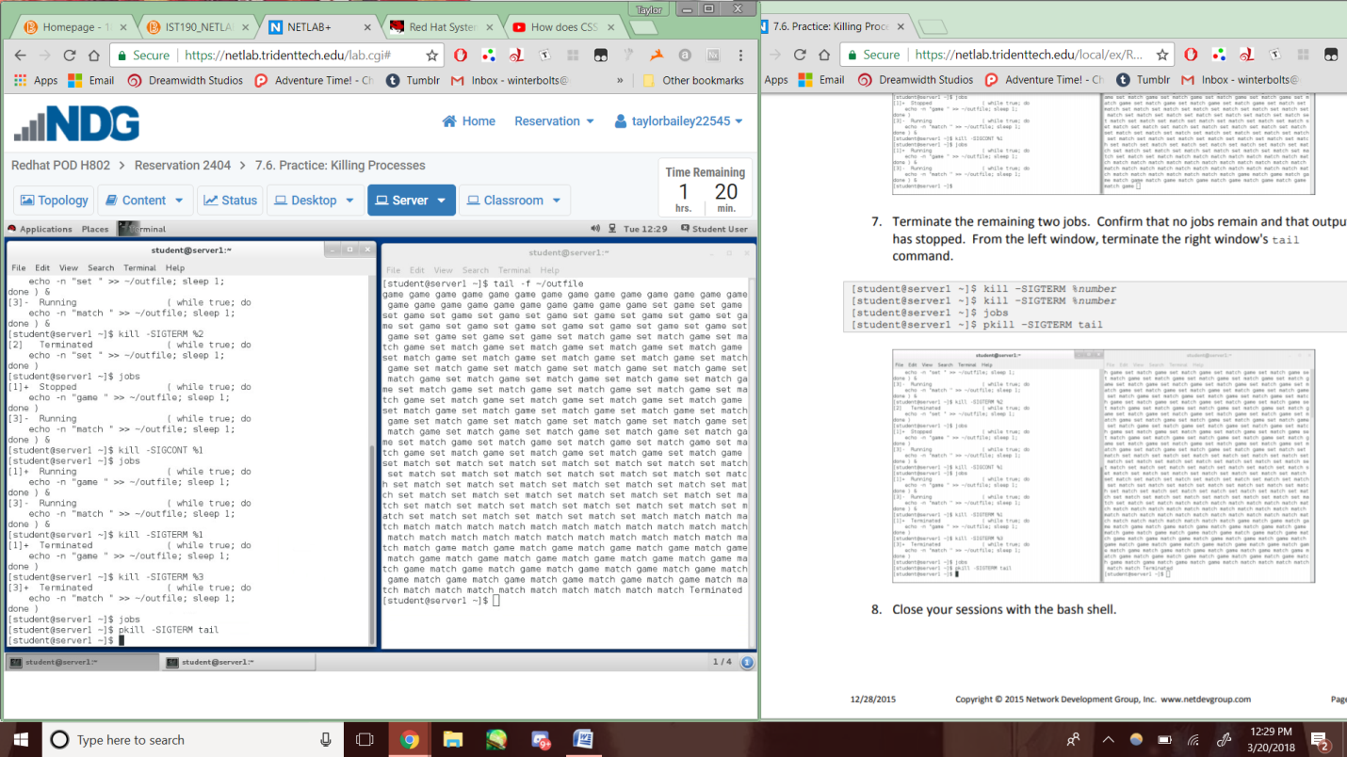

Lab4-7.8-12c

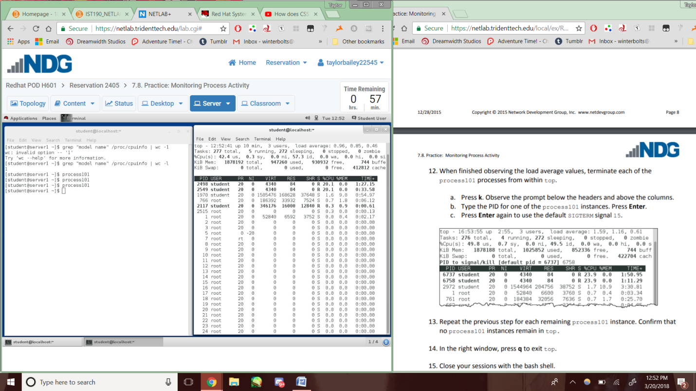

Lab4-7.9-13

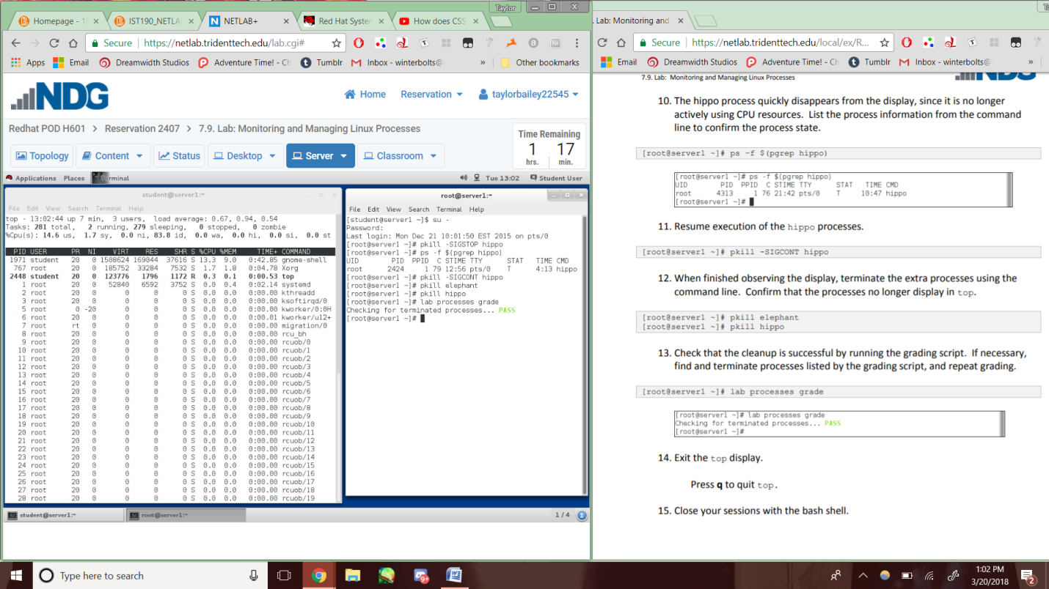

Lab4-8.2-5

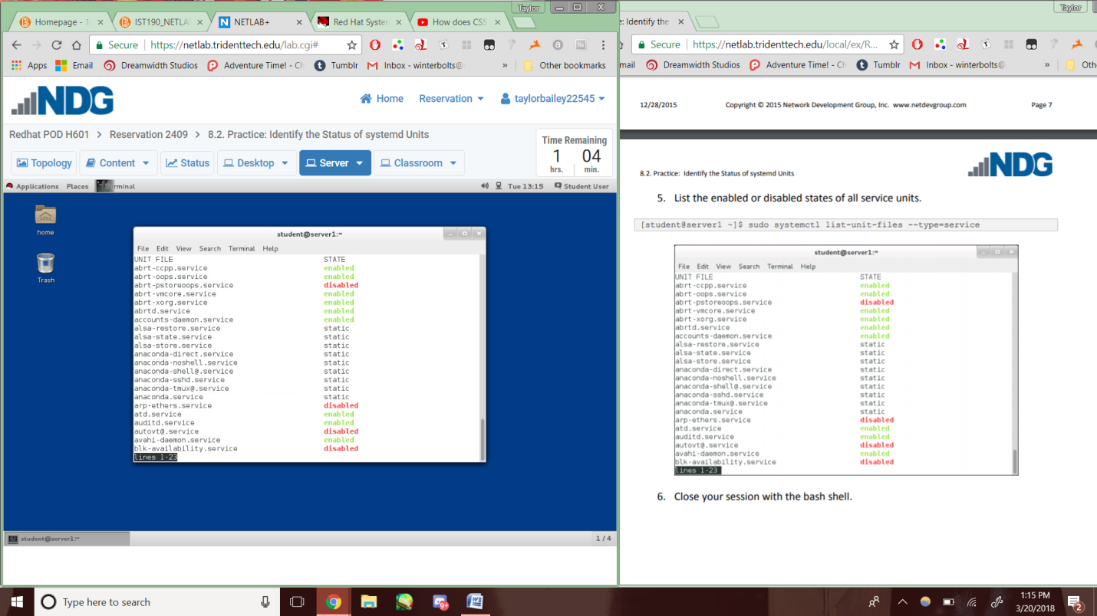

Lab4-8.4-7

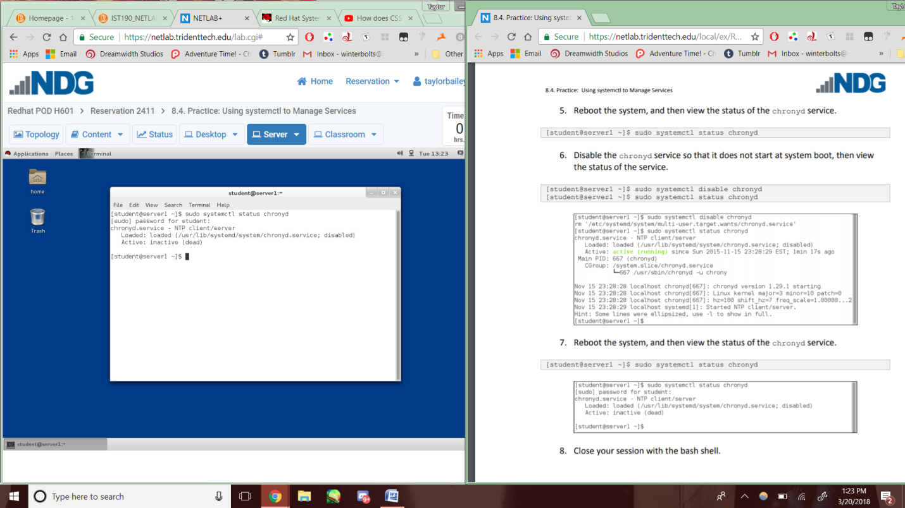

Lab4-8.5-5

